

* 1. Packet-switched network because those can handle variable bitrates
  2. No, because the 10MBps capacity is plenty for the 5.5MBps bitrate of the network



* 1. 20 people.



* 1. 15%
  2. (80 choose n) \* 0.15^n \* 0.85^(80-n)
  3. 1 - n=0Σ19 (80 choose n) \* 0.15^n \* 0.85^(80-n)



* 1. (d1/s1 + L/R1) + (d2/s2 + L/R2) + (d3/s3 + L/R3) + (2 \* tproc)



* 1. 0.134 seconds

1. 7160 seconds = 7.16 milliseconds



1. min { Ri1, Ri2,......RiN}



* 1. TR/R(1-T) + P/R = P/R(1-T)



* 1. 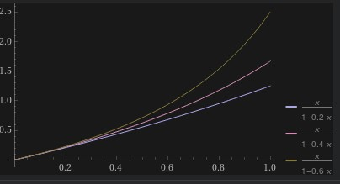



* 1. 1/(ρ-a)



1. 1. Time from source to first packet switch = 0.8 sec



Time from host to host = 2.4 sec



* 1. Time from source host to first switch = 0.125 milliseconds

Time the second packet will be received at first switch = 0.25 milliseconds



* 1. 100.25 milliseconds. It’s faster than with store-and-forward p/s



* 1. With message segmentation, the packets have to be arranged in a sequence and if one is missing the whole meddage is lost. Also, there is more overhead going on in the routers because there are more (smaller) packets and therfore more headers.

